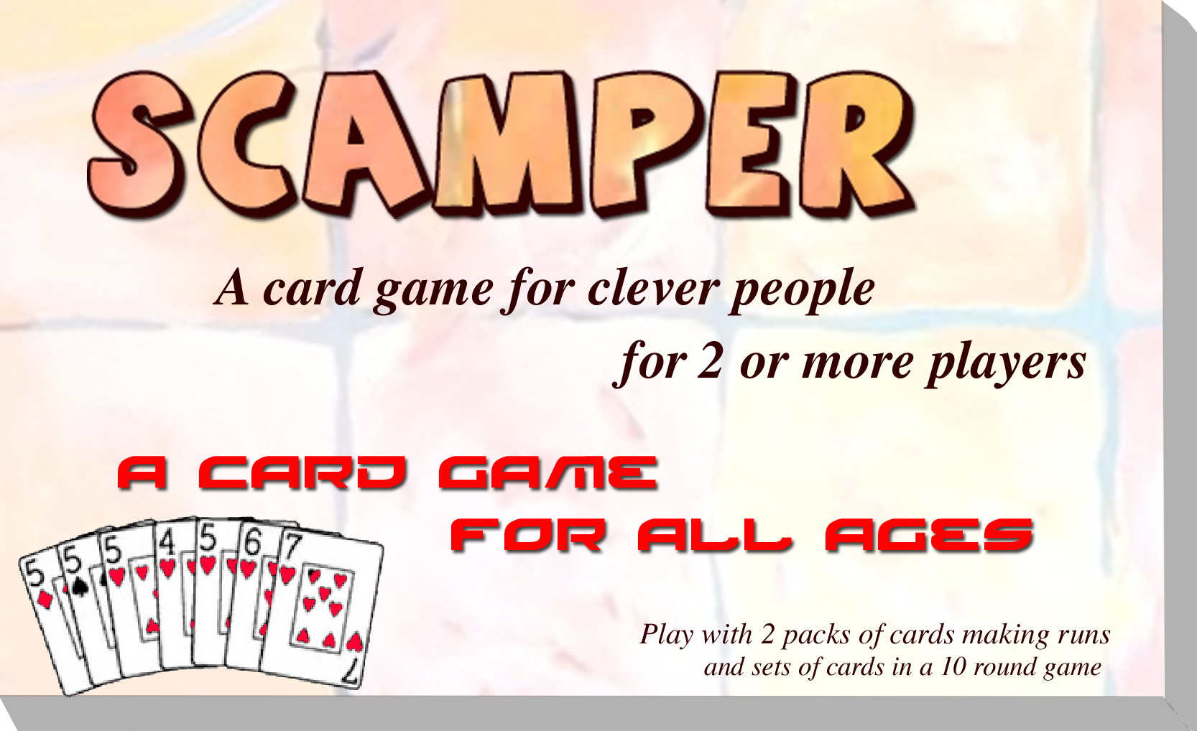

**Game rules & Score sheets**

**Scamper:** Is a game of cards where you need to make melds of sets (3, 4, 5, 6, 7 or 8 of a kind etc.) or runs of 3, 4, 5, 6, 7 or 8 of the same suit. (As required for each round). Then discard all your cards to go out, players left with cards in hand count up the total and their score is tallied for each round. **The player with the lowest score wins**. Each round is different in set and run requirements.

Player with the lowest score after nine/ten rounds wins, players can nominate how many rounds to use.

Players can suggest new combinations of melds. However 9/10 rounds is sufficient for about one hours play.

**Sequence:** players can lay down more than the required minimum. Wild cards are optional

|  |  |  |  |
| --- | --- | --- | --- |
| **Round one** | 2 Sets of 3 | 2 sets (minimum 3 in sequence) | One wild per set |
| **Round two** | 2 Runs of 3 | 2 runs (minimum 3 of a kind each) | One wild per run |
| **Round three** | 1 Set of 3 & 1 Run of 4 | 1 set of 3 (minimum 3 of a kind) and 1 run of 4 | One wild per set One wild per run |
| **Round four** | 3 Sets of 3 | 3 sets of 3 (minimum 3 of a kind each) | One wild per set |
| **Round five** | 1 Set of 3 & 1 Run of 5 | 1 set of 3 (minimum 3 of a kind) and 1 run of 5 | One wild per set  Two wild per run |
| **Round six** | 2 Sets of 3 & 1 Run of 4 | 2 sets of 3 (minimum 3 of a kind) and 1 run of 4 | One wild per set One wild per run |
| **Round seven** | 1 Set of 3 & 1 Run of 7 | 1 set of 3 (minimum 3 of a kind) and 1 run of 7 | One wild per set Three wild per run |
| **Round eight** | 1 Run 4 & 1 Run of 5 | 1 run of 4 and 1 run of 5 | One wild per run |
| **Round nine** | 1 Run of 8 | 1 run of 8 | Three wild per run |
| **Round ten** | 1 Set of 8 | 1 set of 8 | Three wild per set |

All runs must be in suit, if you use wild cards:- you must have more natural cards than wild cards:-

A run of 3 can be all natural in the same suit in sequence or 2 natural and 1 wild card

A run of 4 can be all natural in the same suit in sequence or 3 natural and 1 wild card

A run of 5 can be all natural in the same suit in sequence or 3 natural and 2 wild cards

A run of 6 can be all natural in the same suit in sequence or 4 natural and 2 wild cards

A run of 7 can be all natural in the same suit in sequence or 4 natural and 3 wild cards

A run of 8 can be all natural in the same suit in sequence or 5 natural and 3 wild cards

A set of 3 can be all natural same rank or 2 natural and 1 wild card

A set of 4 can be all natural same rank or 3 natural and 1 wild card

A set of 5 can be all natural same rank or 3 natural and 2 wild cards

A set of 6 can be all natural same rank or 4 natural and 2 wild cards

A set of 7 can be all natural same rank or 4 natural and 3 wild cards

A set of 8 can be all natural same rank or 5 natural and 3 wild cards

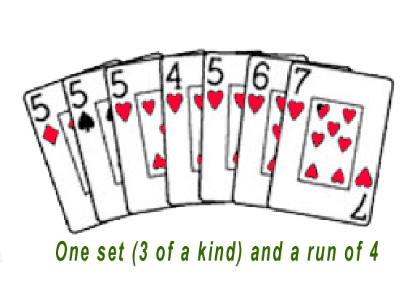

Note: in a set the wild 2 can also be used as a natural card.

A set or group in card games is a scoring combination consisting of three or more playing cards of the same rank A run, straight or sequence is a combination of playing cards where cards have consecutive rank values.

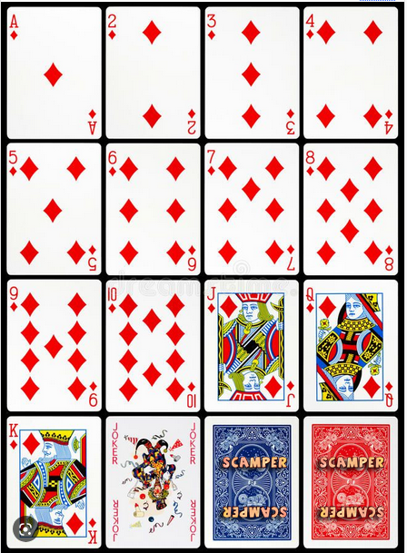**The Decks:** A minimum of two players is required however you can play any reasonable number of players from 2 to 10. A minimum of two decks is required. Each deck has 52 cards and two Jokers. Basically, you need two decks for every two people playing. As you run out of cards in the pickup deck you can add another deck to the game or replay the round. (see: continuing play)

2-3 players 2 packs all cards plus 2 jokers

**4-5 players 3 packs all cards plus 2 jokers**

5-6 players 3 packs all cards plus 2 jokers

**7-8 players 4 packs all cards plus 2 jokers**

plus (2 packs for every additional 2 players)

Players deal for dealer = highest deals first then in sequence left to right. (Jokers and Two's don't count for highest dealer), equal highest players draw again till one is decided.

(First dealer receives - 20 off their score).

Players are dealt eight cards for each round, the remaining pile is placed face down on the table, the top one is revealed as the discard card, the first player may pick this up or pass this card onto the player on their left (if passed on, then the receiving player is also given another card from the top of the pile face down). The player in play then takes the next top card for his/her turn.

Once the initial meld is made for that round, the player in play, (who's turn it is) can lay down their meld for that round, and can lay down any other sets or runs that they have. If other players are already down they can exchange natural cards for wild cards in the sets or runs as laid down, or add to the other players sets or runs with more cards in the meld. But must do this BEFORE playing their discard card or going out.

At the end of their turn the player discards one card he/she doesn't want. Any initial melds must be made before discarding a card. Once a card is discarded the round for that player ends, if a challenge is made it MUST be made before the next player plays. If found to be an incorrect play, the player is penalised additional 50 points, and the player MUST pick up the cards, if however the challenger is incorrect the challenger is penalised an additional 20 points.

Players make melds in sequence, acording to the round being played, the Ace is high i.e. Ace, King Queen. The player must discard one card to go out.

**Advanced play** The Ace can only be used as high, deuces and jokers are wild.

You cannot discard wild cards, or jokers (except when going out). You can use a deuce as a natural two in a run in its suit (i.e. 2, 3, 4 diamonds, or As in set of 8 could be 3’s,4’s,5’s,6’s,7’s,8’s,9’s,10’s, Jack’s, Queen’s, King’s or Ace’s. in a mixture of Diamonds, Spades, Clubs or Hearts. You can include 3 wild cards in the set of, but you cannot lay down three deuces as a set of three.

Once melded you can add as many deuces or jokers to the run, or other player's melds of sets or runs and players can exchange natural cards for wild cards once they have made their meld and can add new sequences (sets or runs) once they are down, you can maintain the natural card to wild card ratio but normally once a meld is made any number of wild cards can be played for any pair or adding to other completed melds. i.e. you can put 3 wild cards a on any run that has been put down or on any set that includes 2 natural cards.

Once a player has laid down their meld they cannot pick it back up or change their hand. Players in turn can change wild cards from other players' hands but not from their own melds.

Once melded the player can immediately create more sets and runs, on their own or other player melds, however they must also discard one card (not a wild card) for the next player. If going out however a wild card can be the last card discarded. Once the round is conclude the scores are tallied and added to previous scores and the next person in line deals the next round. Cards are shuffled and the next player deals, (If the player deals exactly the correct number of cards including the face card -20 is deducted for their score). However if there is a miss deal 20 is added to their score.

At no time can other players assist other players or advise which cards are available, if a player misses a pick up that is just tough luck! Penalty for offering advice is 20 points added to their score.

Players can go out (Scamper) at any time so long as they complete all melds and have a discard card (in this instance a wild card can be use as a discarded card).

**Continuing play:** If all the cards are used and the last player cannot go out with a discard card, the game is forfeited and a replay of the round must be replayed. (Frustrating for players that are down but can't go out). You can add another pack if you wish but decide which rule to apply before the game commences.

Held cards (cards are not counted for any for melds already down) are added up for remaining players and tallied on the score sheet. After the all the rounds have all been played the lowest score wins.

|  |  |
| --- | --- |
| **Losing players count cards remaining in hand**  **(not including melds already placed)** | **Card scores** |
| **Joker** | 50 points each |
| **Deuces** | 20 points each |
| **Ace** | 20 points each |
| **King to 8** | 10 points each |
| **7 to 3** | 5 points each |
| **Benefits or Penalties (Advanced Rules only)** | |
| Dealing correct number of cards from your hand | bonus -20 off their score |
| Miss Deal | penalty = add 20 points |
| Failure to declare "Scamper" (one card remaining) | penalty = add 20 points |
| Incorrect Challenge | penalty = add 20 points |
| Penalty for offering advice | penalty = add 20 points |
| Incorrect lay down of meld (too many wilds) | penalty = add 20 points |

**SCAMPER SETS N' RUNS 2 Players**

|  |  |  |  |
| --- | --- | --- | --- |
| Name  • Dealer |  |  | Melds |
| 1 Score | • |  | 2 Sets of 3 |
| 2 Score |  | • | 2 Runs of 3 |
| Total |  |  |  |
| 3 Score | • |  | 1 Set of 3 & Run of 4 |
| Total |  |  |  |
| 4 Score |  | • | 3 Sets of 3 |
| Total |  |  |  |
| 5 Score | • |  | 1 Set of 3 & Run of 5 |
| Total |  |  |  |
| 6 Score |  | • | 2 Sets of 3 & Run of 4 |
| Total |  |  |  |
| 7 Score | • |  | 1 Set of 3 & Run of 7 |
| Total |  |  |  |
| 8 Score |  | • | 1 Run 4 & 1 Run of 5 |
| Total |  |  |  |
| 9 Score | • |  | Run of 8 |
| Total |  |  |  |
| 10 Score |  | • | 8 of a Kind |
| Total |  |  |  |
| Winner |  |  |  |

**SCAMPER SETS N' RUNS 3 Players**

|  |  |  |  |  |
| --- | --- | --- | --- | --- |
| Name  • Dealer |  |  |  | Melds |
| 1 Score | • |  |  | 2 Sets of 3 |
| 2 Score |  | • |  | 2 Runs of 3 |
| Total |  |  |  |  |
| 3 Score |  |  | • | 1 Set of 3 & Run of 4 |
| Total |  |  |  |  |
| 4 Score | • |  |  | 3 Sets of 3 |
| Total |  |  |  |  |
| 5 Score |  | • |  | 1 Set of 3 & Run of 5 |
| Total |  |  |  |  |
| 6 Score |  |  | • | 2 Sets of 3 & Run of 4 |
| Total |  |  |  |  |
| 7 Score | • |  |  | 1 Set of 3 & Run of 7 |
| Total |  |  |  |  |
| 8 Score |  | • |  | 1 Run 4 & 1 Run of 5 |
| Total |  |  |  |  |
| 9 Score |  |  | • | Run of 8 |
| Total |  |  |  |  |
| 10 Score |  |  |  | 8 of a Kind |
| Total |  |  |  |  |
| Winner |  |  |  |  |

**SCAMPER SETS N' RUNS 4 Players**

|  |  |  |  |  |  |
| --- | --- | --- | --- | --- | --- |
| Name  • Dealer |  |  |  |  | Melds |
| 1 Score | • |  |  |  | 2 Sets of 3 One wild per set |
| 2 Score |  | • |  |  | 2 Runs of 3 One wild per set |
| Total |  |  |  |  |  |
| 3 Score |  |  | • |  | 1 Set of 3 & Run of 4 One wild per set |
| Total |  |  |  |  |  |
| 4 Score |  |  |  | • | 3 Sets of 3 One wild per set |
| Total |  |  |  |  |  |
| 5 Score | • |  |  |  | 1 Set of 3 & Run of 5 One wild per 3 two wild set 5 |
| Total |  |  |  |  |  |
| 6 Score |  | • |  |  | 2 Sets of 3 & Run of 4  One wild per set 3 or 4 |
| Total |  |  |  |  |  |
| 7 Score |  |  | • |  | 1 Set of 3 & Run of 7  One wild per set 3 three per 7 |
| Total |  |  |  |  |  |
| 8 Score |  |  |  | • | 1 Run 4 & 1 Run of 5  One wild per set 4 two per 5 |
| Total |  |  |  |  |  |
| 9 Score | • |  |  |  | Run of 8  3 wild per set 8 |
| Total |  |  |  |  |  |
| 10 Score |  | • |  |  | 8 of a Kind  3 wild per set 8 |
| Total |  |  |  |  |  |
| Winner |  |  |  |  |  |

**SCAMPER SETS N' RUNS 5 Players**

|  |  |  |  |  |  |  |
| --- | --- | --- | --- | --- | --- | --- |
| Name  • Dealer |  |  |  |  |  | Melds |
| 1 Score | • |  |  |  |  | 2 Sets of three |
| 2 Score |  | • |  |  |  | 2 Runs of 3 |
| Total |  |  |  |  |  |  |
| 3 Score |  |  | • |  |  | 1 Set of 3 & Run of 4 |
| Total |  |  |  |  |  |  |
| 4 Score |  |  |  | • |  | 3 Sets of 3 |
| Total |  |  |  |  |  |  |
| 5 Score |  |  |  |  | • | 1 Set of 3 & Run of 5 |
| Total |  |  |  |  |  |  |
| 6 Score | • |  |  |  |  | 2 Sets of 3 & Run of 4 |
| Total |  |  |  |  |  |  |
| 7 Score |  | • |  |  |  | 1 Set of 3 & Run of 7 |
| Total |  |  |  |  |  |  |
| 8 Score |  |  | • |  |  | 1 Run 4 & 1 Run of 5 |
| Total |  |  |  |  |  |  |
| 9 Score |  |  |  | • |  | Run of 8 |
| Total |  |  |  |  |  |  |
| 10 Score |  |  |  |  | • | 8 of a Kind |
| Total |  |  |  |  |  |  |
| Winner |  |  |  |  |  |  |

**SCAMPER SETS N' RUNS 6 Players**

|  |  |  |  |  |  |  |  |
| --- | --- | --- | --- | --- | --- | --- | --- |
| Name  • Dealer |  |  |  |  |  |  | Melds |
| 1 Score | • |  |  |  |  |  | 2 Sets of three |
| 2 Score |  | • |  |  |  |  | 2 Runs of 3 |
| Total |  |  |  |  |  |  |  |
| 3 Score |  |  | • |  |  |  | 1 Set of 3 & Run of 4 |
| Total |  |  |  |  |  |  |  |
| 4 Score |  |  |  | • |  |  | 3 Sets of 3 |
| Total |  |  |  |  |  |  |  |
| 5 Score |  |  |  |  | • |  | 1 Set of 3 & Run of 5 |
| Total |  |  |  |  |  |  |  |
| 6 Score |  |  |  |  |  | • | 2 Sets of 3 & Run of 4 |
| Total |  |  |  |  |  |  |  |
| 7 Score | • |  |  |  |  |  | 1 Set of 3 & Run of 7 |
| Total |  |  |  |  |  |  |  |
| 8 Score |  | • |  |  |  |  | 1 Run 4 & 1 Run of 5 |
| Total |  |  |  |  |  |  |  |
| 9 Score |  |  | • |  |  |  | Run of 8 |
| Total |  |  |  |  |  |  |  |
| 10 Score |  |  |  | • |  |  | 8 of a Kind |
| Total |  |  |  |  |  |  |  |
| Winner |  |  |  |  |  |  |  |